Pokémon 4e
Kanto Campaign Setting

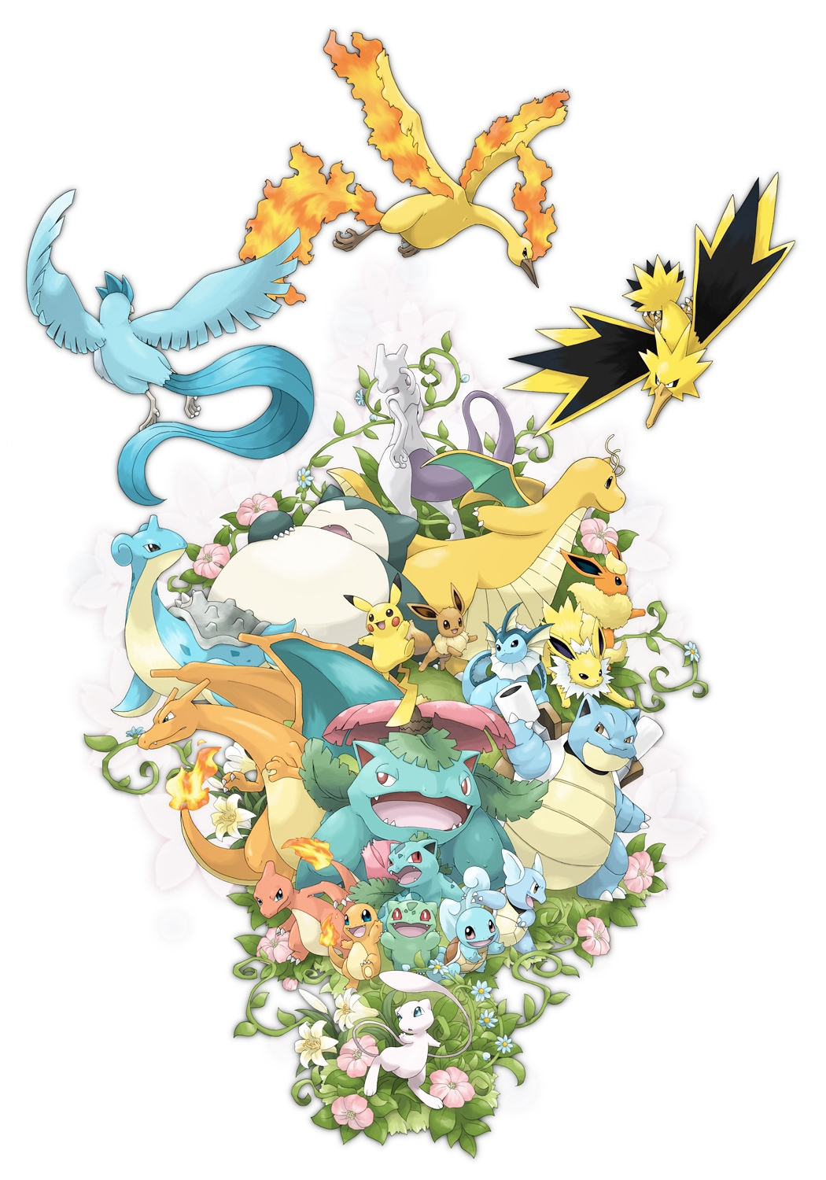

Author
Sarah Herzog

Contributors
Andrew Bush
Greg Campagna
Boris Charney
Lynx Cheam
Anthony Laureano
Amy Lowell
Kevin Price

Play-Testers

Brittany Burton ♦ Andrew Bush ♦ Greg Campagna ♦ Boris Charney ♦ Lynx Cheam ♦ TJ Cole
Natasha Furby ♦ Logan Herzog ♦ Rachael Herzog ♦ Crystal Laney ♦ Amy Lowell
Tim Stegeman

TABLE OF CONTENTS
INTRODUCTION 1
LOCATIONS 1
PALLET TOWN 1
PLACES 1
PEOPLE 2
POKEMON 2
QUESTS 2
GYMS 3
POKEMON 3
STARTING POKEMON 3
POKEMON STAT BLOCKS 3
ALL POKEMON BY NUMBER 4
POWERS 7

CHAPTER ONE

INTRODUCTION

Welcome to the world of Pokémon! This book is designed for Pokemon Masters (Game/Dungeon Masters) who want to run a Pokemon campaign in Kanto, the setting of the first three Pokemon Gameboy games and the first season of the Pokemon TV series. If you are a player, please don't read this book! There is information here that only the PM should know. If there's something you want to know about, ask your PM if it's alright first.

This book will not teach you how to to play or run a game of Pokemon 4e. To learn to play, please read the Trainer's Handbook. To learn to run a Pokemon 4e game, please read the Pokemon Master's Guide.

In this book, you'll find maps of Kanto and some major areas in Kanto, descriptions of each major city and area of interest, and information about what Pokemon can be found in each area. For convenience, the skill checks needed to know about and find Pokemon in each of these areas is also given.

This book is also the place to find all of the stats and powers for each Pokemon that can be found in Kanto. Additionally, it contains full sample NPCs for the Kanto gyms and the Kanto elite 4.

Finally, we have also included some campaign and adventure ideas, both overall stories as well as location-specific quests.

CHAPTER TWO

LOCATIONS

TODO: Each area in Kanto. Big map of Kanto. Pokemon to be found in each area, information about each city.
WEATHER for each city.

PALLET TOWN

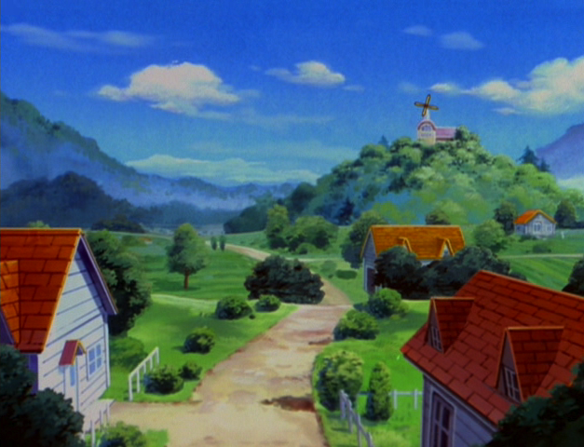
Pallet Town is located in western Kanto, and is the traditional starting point for Pokémon journeys in Kanto. Professor Oak, the leading Pokémon researcher in the Kanto area, maintains a lab here. It is also the location where Pokémon stored via the Kanto Pokémon storage system are located. There are several other interesting features including the Oak Corral where Professor Oak observes Pokémon living as in their natural habitats; and the Xanadu Nursery, a large greenhouse full of exotic plants.

WEATHER

Spring
01-50 | Partially Cloudy
51-80 | Heavy Rain
81-90 | Intense Sunlight
91-00 | Fog
Summer
01-50 | Intense Sunlight
51-90 | Partially Cloudy
91-00 | Thunderstorm (Heavy Rain)
Fall
01-50 | Partially Cloudy
51-75 | Heavy Rain
76-90 | Intense Sunlight
91-00 | Fog
Winter
01-50 | Partially Cloudy
51-75 | Heavy Rain
76-00 | Snow/Hailstorm

PLACES

Professor Oak's Lab: Professor Oak maintains a state-of-the-art laboratory where he carries out research about Pokémon. This is also the location where new trainers can come to choose their first Pokémon. In the old days, Professor Oak only offered three choices, but rumor has it that thanks to the operations of Oak Corral he is now able to raise more Pokémon for trainers to choose from. Regardless, it's clear that the easiest way for a trainer to start their Pokémon journey is to come to Oak's Lab. In exchange for granting their first Pokémon, Oak also gives trainers a Pokédex to fill up, hoping that their experiences will help him in his research.

Oak Corral: The Oak Corral is built on the outskirts of Pallet Town. It's a massive, sprawling Pokémon reserve where Pokémon can live naturally. Professor Oak created the reserve with elements from various landscapes so many different types of Pokémon would feel at home. Not all Pokémon there get along well, so there are some Pokémon which act as peacekeepers between them. Many of the Pokémon who are in storage are allowed to roam here.

Xanadu Nursery: The Xanadu Nursery is a huge greenhouse where exotic flowers and plants are grown. Among them is a rare flower which contains Stun Spore. The owner and manager of the nursery is a trainer named Florinda Showers, and her partner is a man named Potter. Together, along with Florinda's Gloom, they run the nursery.

PEOPLE



Professor Oak: Professor Oak is the leading Pokémon researcher in Kanto. Oak focuses his research on Pokémon-human relationships. He is in charge of handing out starter Pokémon for the Kanto region, and thanks to the Oak Corral, has a large selection of starters to choose from. Oak also presents many trainers with a Pokédex, so they can help him in his research as they Journey, and often sends rewards based on the information the trainers can gather. In his past, Oak was a Pokémon trainer and battler.

Florinda Showers: Florinda is the owner of the Xanadu Nursery. She and her husband Potter manage the nursery, along with her Pokémon Gloom.

POKEMON

Gift Pokémon: Professor Oak will grant new trainers their choice of starting Pokémon from the following list:

Pokémon | Source | LVL | Rarity
Bulbasaur | Gift from Professor Oak | 1 | Common
Charmander | Gift from Professor Oak | 1 | Common
Squirtle | Gift from Professor Oak | 1 | Common
Pichu | Gift from Professor Oak | 1 | Common
Cleffa | Gift from Professor Oak | 1 | Common
Machop | Gift from Professor Oak | 1 | Common
Abra | Gift from Professor Oak | 1 | Common
Dratini | Gift from Professor Oak | 1 | Common

Fishing/Surfing:

Pokémon | Source | LVL | Rarity
Magikarp | Old Rod | 1 | Common
Poliwag | Good Rod | 1 | Common
Goldeen | Good Rod | 1 | Common
Psyduck | Super Rod | 1 | Scarce
Slowpoke | Super Rod | 1 | Scarce

QUEST HOOKS

Plant Poachers: Someone has been stealing valuable plants from the Xanadu Nursery, including the rare plant which contains Stun Spore. Gloom, who normally protects the Nursery, has been unable to detect the thieves. Florinda Showers will ask any visiting trainers for help investigating the mystery. Possible culprits include Team Rocket, a group of reclusive Pokémon who need the plants as medicine, or a rival who wants to set up a nursery of their own.

Corral Chaos: Something is making the Pokémon in the Oak Corral restless. In particular, the Taurus have been stampeding, and this is dangerous since other Pokémon can be injured in the stampede. Oak asks passing trainers to investigate the situation and find out what is disturbing the Corral Pokémon. Possible culprits include Team Rocket sneaking onto the grounds to try to steal Pokémon, a (very young) Pokéwatcher who hasn't yet learned how to hide properly, or a wild Pokémon who has wandered into the Corral due to the plentiful food and either purposefully or not, scares the Taurus and other Pokémon.

ROUTE 1

Route 1 is a fairly short path connecting Pallet town to the south with Viridian City to the north. It is characterized by grassy fields and hills. The path north to Viridian City is a rough one, requiring passage through the tall grass where various Pokémon make their homes. The trip south to Pallet Town is much safer, taking advantage of ledges and slopes to avoid tall grass.

WEATHER

Spring
01-50 | Partially Cloudy
51-80 | Heavy Rain
81-90 | Intense Sunlight
91-00 | Fog
Summer
01-50 | Intense Sunlight
51-90 | Partially Cloudy
91-00 | Thunderstorm (Heavy Rain)
Fall
01-50 | Partially Cloudy
51-75 | Heavy Rain
76-90 | Intense Sunlight
91-00 | Fog
Winter
01-50 | Partially Cloudy
51-75 | Heavy Rain
76-00 | Snow/Hailstorm

PEOPLE

Jordan Summers: Jordan Summers, a manager for Viridian City's Pokémart, often takes walks along Route 1 and hands out free potion samples, one per trainer.

POKEMON

Daytime:

Pokémon | Source | LVL | Rarity
Pidgey | Grass & Trees | 1 | Common
Rattata | Grass | 1 | Common
Spearow | Grass & Trees | 1 | Uncommon
Caterpie | Trees | 1 | Scarce
Weedle | Trees | 1 | Scarce

Nighttime:

Pokémon | Source | LVL | Rarity
Rattata | Grass | 1 | Common
Caterpie | Trees | 1 | Scarce
Weedle | Trees | 1 | Scarce

QUEST HOOKS

Lost and Lonely: Jeffrey Lainie is a young boy from Pallet Town, too young to yet have his own Pokémon. Never-the-less, he's journeyed out into Route 1, determined to catch a Pokémon of his own. Unfortunately he didn't realize how dangerous wild Pokémon can be to those without protection.

VIRIDIAN CITY

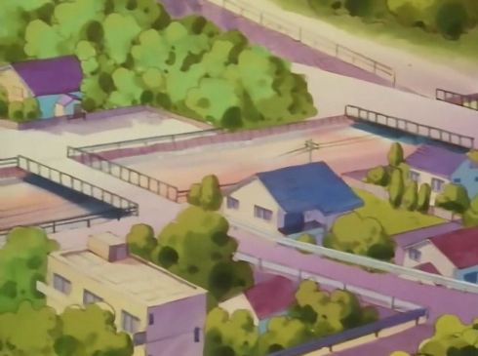
Viridian City is most likely both the first and the last city young trainers will come to when traveling around Kanto. It's gym leader is quite powerful, so its recommended to PMs to have this gym be closed on first arrival of the trainers in town. This also gives them a little more time to prepare and train before they need to take on a full Gym.

WEATHER

Spring
01-50 | Partially Cloudy
51-80 | Heavy Rain
81-90 | Intense Sunlight
91-00 | Fog
Summer
01-50 | Intense Sunlight
51-90 | Partially Cloudy
91-00 | Thunderstorm (Heavy Rain)
Fall
01-50 | Partially Cloudy
51-75 | Heavy Rain
76-90 | Intense Sunlight
91-00 | Fog
Winter
01-50 | Partially Cloudy
51-75 | Heavy Rain
76-00 | Snow/Hailstorm

PEOPLE

Jordan Summers: Jordan Summers, who often takes walks along Route 1, is the manager for Viridian City's Pokémart. He is a cheerful fellow who frequently gives out free potion samples.

Rusty Shackleford: Rusty runs the New Trainer Tourney in Viridian City. He is a loud and cheerful announcer, and enjoys wearing gaudy clothes, especially brightly colored bowties.

POKEMON

Fishing/Surfing:

Pokémon | Source | LVL | Rarity
Magikarp | Old Rod | 2 | Common
Poliwag | Good Rod | 2 | Common
Goldeen | Good Rod | 2 | Common
Psyduck | Super Rod | 2 | Scarce
Slowpoke | Super Rod | 2 | Scarce

QUEST HOOKS

New Trainer Tourney: Over the years, Viridian has become a great place for new trainers to test out their freshly caught Pokémon. Every weekend, a small tournament is held where trainers can test their abilities against others. Trainers compete in teams of three or four against other new trainers, with Pokémon ranging from level 1-3. Common prizes include: potion (consolation prize), 5 pokeballs (third prize), X Attack or X Energy (second prize), or a Pink Bow +1 (first prize).

Pokémart Plunder: Someone has robbed the local Pokémart of all its pokéballs! To be able to access pokéballs, and for a considerable reward, trainers can help Officer Jenny track down the thieves. Possible culprits include Team Rocket, a group of Pokémon rights activists, or a local ruffian who dislikes Jordan Summers and wants to cause trouble for him.

ROUTE 2

Route 2 connects Viridian City to the south with Pewter City to the north. It also contains Viridian Forest (which will be discussed as a separate zone) and an entrance to Diglett's Cave. With a Pokémon who can use Cut, trainers can take a shortcut through the thick underbrush and bypass Viridian Forest altogether. Cut is also required to access Diglet's Cave.

A gate and house are located on the eastern side of Route 2, accessible only by Cut from the two nearby towns.

WEATHER

Spring
01-50 | Partially Cloudy
51-80 | Heavy Rain
81-90 | Intense Sunlight
91-00 | Fog
Summer
01-50 | Intense Sunlight
51-90 | Partially Cloudy
91-00 | Thunderstorm (Heavy Rain)
Fall
01-50 | Partially Cloudy
51-75 | Heavy Rain
76-90 | Intense Sunlight
91-00 | Fog
Winter
01-50 | Partially Cloudy
51-75 | Heavy Rain
76-00 | Snow/Hailstorm

PEOPLE

Mark Rabble: Mark is an older gentleman who lives with his wife in the eastern edge of Route 2. Trainers coming from Pewter City or Viridian City will need Cut in order to access his house. Mark can't really get around too well anymore but has always wanted to catch an Abra, and is happy to trade his Mr. Mime for one.

Scientist Ron Jones: Ron is one of professor Oak's field aides, stationed at the gate on the eastern side of Route 2 (Cut required to reach him from either of the nearby cities). He is stationed in this area to observe the bug Pokémon in Viridian Forest. Ron will award the HM Flash to trainers who have owned at least 10 different Pokémon.

POKEMON

Daytime:

Pokémon | Source | LVL | Rarity
Pidgey | Grass & Trees | 2 | Common
Rattata | Grass | 2 | Common
Caterpie | Grass & Trees | 2 | Uncommon
Weedle | Grass & Trees | 2 | Uncommon
Nidoran | Grass | 2 | Scarce
Spearow | Grass & Trees | 2 | Scarce
Pikachu | Grass | 3 | Rare

Nighttime:

Pokémon | Source | LVL | Rarity
Rattata | Grass | 2 | Common
Caterpie | Trees | 2 | Uncommon
Weedle | Trees | 2 | Uncommon
Nidoran | Grass | 2 | Scarce

QUEST HOOKS

Aide Needs Aid: Professor Oak's aide, Scientist Ron Jones, has been noticing a strange phenomenon with the bug Pokémon of Viridian Forest. It seems they have recently begun migrating out of the forest in large swarms, and are wreaking havoc on Route 2's plant life. Ron asks the trainers to investigate the cause and help the bug Pokémon return to their forest homes. Possible causes include Team Rocket stealing bug Pokémon in the forest, a fire Pokémon that has moved into the forest and started minor forest fires, or a surge in bird Pokémon population.

VIRIDIAN FOREST

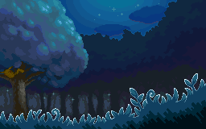
Viridian Forest is located along Route 2, and most people must pass through it to travel between Pewter City and Viridian City. It is a perfect habitat for bug Pokémon, and many different types of bugs can be found under the boughs of the trees here. Bug catching trainers are also found in abundance. In addition, the dim light and underbrush means many items have been lost in this area, which the savvy trainer might find.

WEATHER

Spring
01-50 | Partially Cloudy
51-80 | Heavy Rain
81-00 | Fog
Summer
01-25 | Intense Sunlight
26-80 | Partially Cloudy
81-00 | Thunderstorm (Heavy Rain)
Fall
01-50 | Partially Cloudy
51-75 | Heavy Rain
76-00 | Fog
Winter
01-30 | Partially Cloudy
31-50 | Fog
51-75 | Heavy Rain
76-00 | Snow/Hailstorm

PEOPLE

Bug Catchers: Bug catchers are known to frequent Viridian Forest, as it is an ideal place to catch bug Pokémon. Bug catchers are trainers who use mainly bug type Pokémon, and are usually young and eager to battle any trainers who cross their path.

POKEMON

Daytime:

Pokémon | Source | LVL | Rarity
Pidgey | Grass & Trees | 2 | Uncommon
Caterpie | Grass & Trees | 2 | Common
Weedle | Grass & Trees | 2 | Common
Pikachu | Grass | 3 | Rare
Metapod | Grass & Trees | 6 | Rare
Kakuna | Grass & Trees | 6 | Rare

Nighttime:

Pokémon | Source | LVL | Rarity
Caterpie | Trees | 2 | Common
Weedle | Trees | 2 | Common
Metapod | Grass & Trees | 6 | Rare
Kakuna | Grass & Trees | 6 | Rare

QUEST HOOKS

Bugging Bugs: A group of bug catchers have antagonized a Kakuna nesting tree, and the Weedle in the area have converged and pursue the bug catchers relentless. Nearby trainers would probably be rewarded if they helped out.

Protector Pidgeot: The trainers are approached by a wild Pidgeot, much too high level for them to capture. It seems to want the trainers to follow it. The Pidgeot is the guardian of the local Pidgey, and they have been disappearing lately. The Pidgeot shows the trainer several empty Pidgey nests, and does its best to convey that it wants the trainer's help. Possible culprits: Team Rocket, snow Pokémon has moved into the area and is changing their migration patterns, an Arbok has taken up residence and is eating them.

CHAPTER THREE

GYMS

TODO: Each gym in Kanto with example trainers, plus Elite 4.

CHAPTER FOUR

POKEMON

The Pokémon of Kanto are perhaps the most recognizable of all Pokémon, being the original 150. However, over the years several new evolutions of these original Pokémon have been discovered, and these have been included in this chapter as well.

In this chapter, you will find a complete list of Kanto Pokémon and their stats, as well as what areas to find them in, what time of day they like to come out, and what habitat they can be found in (grass, trees, water, caves, etc.). In addition, a knowledge check DC is available to determine how much a trainer might know about a Pokemon ahead of time.

STARTING POKEMON

The traditional starting location for Kanto trainers in Pallet Town, where Professor Oak maintains a collection of Pokémon to give to new trainers. This collection includes the following Pokemon choices:

- Bulbasaur
- Charmander
- Squirtle
- Cleffa
- Pichu
- Machop
- Abra
- Dratini

The PM may choose to allow more or less choices as he or she sees fit. He may or may not allow these starters to be captured in the main world. For Pichu and Cleffa, the PM may choose to have Professor Oak award a Thunder/Moon Stone along with the Pokemon to allow the trainer to evolve the Pokemon when they see fit to do so.

POKEMON STAT BLOCKS

Each Pokémon entry has the following sections:

Name: The Pokémon's name, located at the top left.

Number and Species: The Pokédex number for this Pokémon and it's species, located just below the name.

Image: A representation of what the Pokémon looks like, located just below the name and number/species.

Rarity: The rarity of a Pokémon determines the base Pokémon skill check DC to know about this Pokémon.

Habitat: Where the Pokémon can be found, including type of terrain and time of day active.

Biology: A few details about the Pokémon's physical appearance and abilities.

Behavior: Some details about how the Pokémon acts, both in the wild and toward it's trainer.

Evolutions: The evolution family of this Pokémon, and how each Pokémon evolves.

Ability Scores: The base ability scores for a Pokémon, only given for initial evolutions.

On Evolving: Adjustments to base ability scores gained when evolving, only given for evolved Pokémon.

Type: The Pokémon's elemental type(s).

Size: The Pokémon's size.

Gender: The breakdown of the Pokémon's gender, in percentage. Some Pokémon are genderless.

Happiness: The starting happiness of a Pokémon. Starting happiness is as follows:

Starting Happiness | Adjustment
Low | -2
Normal | 0
High | +2

Growth: Some Pokémon get a boost or penalty to growth rate. These are as follows:

Growth | XP to Level Adjustment
Slow | 10% more XP needed to level
Normal | Normal XP needed to level
Fast | 10% less XP needed to level

Egg Groups: What Pokémon are compatible mates is determined by egg group. If two Pokémon belong to the same egg group, they can mate. If a Pokémon has no egg groups, it cannot mate.

Skills: These are the three skills a Pokémon is trained in.

Qualities: These are the qualities a Pokémon has access to, described in the next chapter.

Basic Attack: The basic attack that this Pokémon can use.

Powers: These are the powers the Pokémon naturally learns by leveling up. It may learn other powers at the PM's discretion.

TODO: List of what powers a Pokémon can learn via Train skill and/or TMs.

ALL POKEMON BY NUMBER

BULBASAUR
#001 – The Seed Pokémon
 | Evolutions:  Bulbasaur → Ivysaur: Level 11  Ivysaur → Venusaur: Level 21
 | Ability Scores: | Str 12  Con 10  Dex 10  Int 14  Wis 12  Cha 14
Rarity: Common  Habitat: Bulbasaur are usually bred in captivity and seldom found in the wild. Very rarely they can be found in secret gardens, plains near fresh water, or deep forests.  Biology: A seed is planted on Bulbasaur's back at birth and grows with it as it matures. It uses this bulb to store energy, and enjoys napping in bright sunlight to soak up energy from the sun.  Behavior: Bulbasaur are considered very mild-mannered and well-behaved. They like to sleep a lot, especially on sunny days, and don't | Ability Scores: | Str 12  Con 10  Dex 10  Int 14  Wis 12  Cha 14
 | Type: | Grass/Poison
 | Size: | Small
 | Gender: | 87% male, 13% female
 | Happiness: | Normal
 | Growth: | Normal
 | Egg Groups: | Grass, Monster
 | Skills: | Endurance, Perception, Nature
 | Qualities: | Overgrow, Chlorophyll
 | Basic Attack: | Tackle
 | Powers: | 1 – Growl  3 – Leech Seed  5 – Vine Whip  7 – Poisonpowder  9 – Sleep Powder  11 – Take Down  13 – Razor Leaf  15 – Sweet Scent  17 – Growth  19 – Double-Edge  21 – Worry Seed  23 – Synthesis  25 – Seed Bomb  27 – Leaf Blade  29 – Solarbeam

IVYSAUR
#002 – The Seed Pokémon
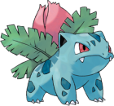 | Evolutions:  Bulbasaur → Ivysaur: Level 11  Ivysaur → Venusaur: Level 21
 | On Evolving: | +2 Int  +2 Wis
Rarity: Common  Habitat: Ivysaur's natural habitat seems to consist of plains with access to large amounts of sunshine and fresh water but can be found in forests and jungles. However, they are rare, as many are in captivity  Biology: Ivysaur, like its pre-evolved form, Bulbasaur, resembles a toad or a quadruped dinosaur, though the patches in its skin cause it to resemble a dinosaur more closely. After evolving from Bulbasaur, Ivysaur grows small fangs and has visible ear insides and pupils. Ivysaur's skin is also a little bit bluer than Bulbasaur's. The most notable difference in Ivysaur's appearance, however, is that its bulb has changed into a pink flower bud with leaves extending. This flower bud is heavy, thus making its back legs grow strong and sturdy to support it, causing it to be unable to rise on its hind legs.  Behavior: Ivysaur are more aggressive than Bulbasaur, although it is still very loyal to its Trainer. When its plant is ready to bloom, it gives off a distinct, strong sweet-smelling aroma and starts swelling. Ivysaur will also start spending more time in sunlight in preparation for its upcoming evolution. Like its plant, exposure to sunlight adds to Ivysaur's strength. | On Evolving: | +2 Int  +2 Wis
 | Type: | Grass/Poison
 | Size: | Medium
 | Gender: | 87% male, 13% female
 | Happiness: | Normal
 | Growth: | Normal
 | Egg Groups: | Grass, Monster
 | Skills: | Endurance, Perception, Nature
 | Qualities: | Overgrow, Chlorophyll
 | Basic Attack: | Tackle
 | Powers: | 1 – Growl  3 – Leech Seed  5 – Vine Whip  7 – Poisonpowder  9 – Sleep Powder  11 – Take Down  13 – Razor Leaf  15 – Sweet Scent  17 – Growth  19 – Double-Edge  21 – Worry Seed  23 – Synthesis  25 – Seed Bomb  27 – Leaf Blade  29 – Solarbeam
CHAPTER FIVE

POWERS

TODO: Qualities, Basic Attacks, Powers. Currently located in a separate document due to formatting issues.

